I cannot print my Results Sheet

Issue
If a customer’s printer is not printing result sheets after a scan, follow these steps to verify and configure the necessary settings.

🔍 Step 1: Check Operator Configuration Settings
- Verify Print Mode
  - Ensure the Printer setting is set to either Manual or Auto in the Operator Configuration Settings.
- Log Into Operator Panel
  - Use the Machine Credentials to access the Operator Panel.
- Confirm Print Setting
  - Make sure the Print setting is not set to OFF.

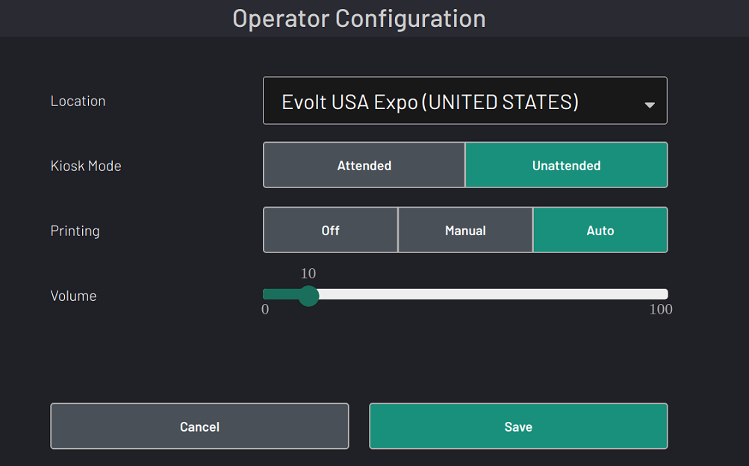

🛠️ Step 2: Printer Configuration & Setup
- Access Printer Settings
  - From the Control Panel, select Printers.
- Add a Printer
  - Press “Add Printer” to begin configuration.
  - Choose connection type: USB or Wi-Fi.
- Select the Correct Printer
  - Choose the appropriate printer model from the list.
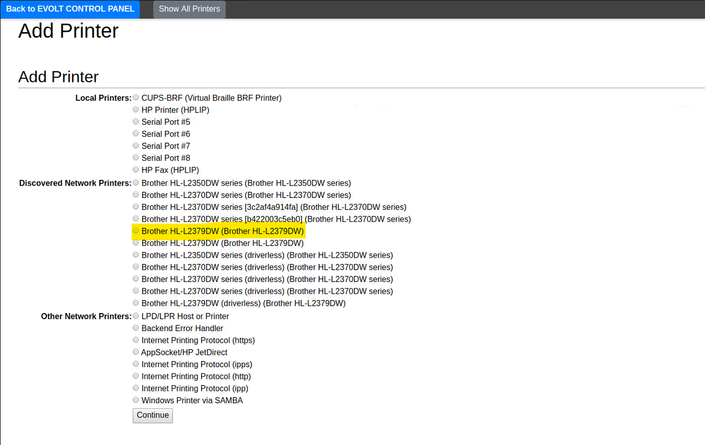

- Continue Setup
  - Press Continue on the next screen.
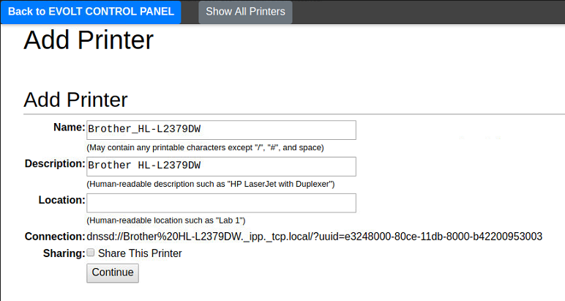

- Choose the Correct Driver
  - Select the driver that matches the printer model.
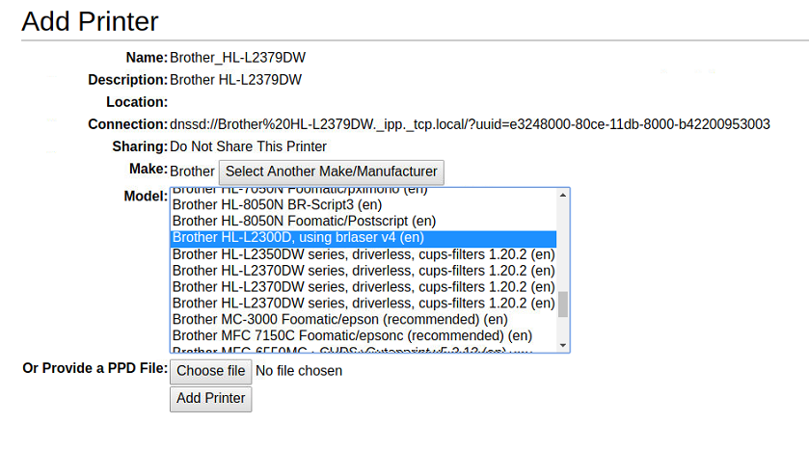

- Finalize Setup
  - Press “Add Printer” to complete the installation.
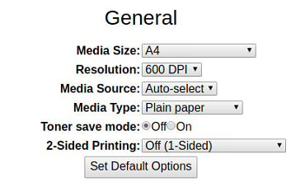

- Set Default Paper Size
  - Configure default settings:
    - Paper Size: Set to A4 for all locations except those in the United States, which should use US Letter.
- Set as Server Default
  - From the Properties Page, set the printer as the Server Default.
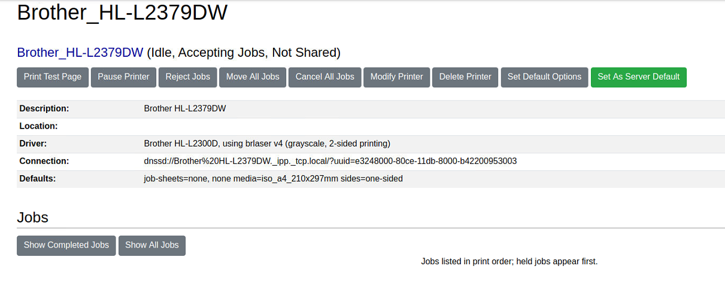

- Test the Printer
  - Have the customer perform a test scan to confirm that the printer outputs the result sheet correctly.

